Edit 302 – Participation Rubric
Name _________________________________ Instructor: Michelle Khatib

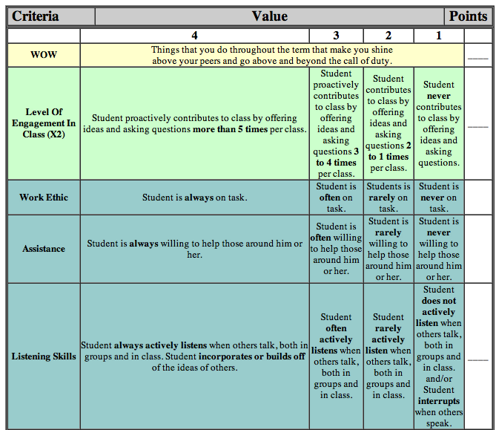
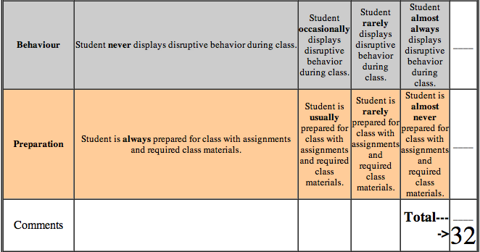

Document from Brad McDiarmid 2012 – Edit 302

